Practical Lab Report : Secure Network Architecture
Prepared by: Omkar Sawant
Platform: TryHackMe — Secure Network Architecture
Date completed: 25 May 2026
Project: Implementing a Secure Network Architecture for a Large Enterprise
Organisation: Spinnaker Analytics

Room completed: 8 tasks · 112 points · User: sawant052

1. Overview
- This report documents the completion of the TryHackMe room 'Secure Network Architecture' as the practical component of Network Segmentation of the project.
- The lab involved configuring a VyOS firewall with zone-based policies to segment a network into distinct zones:
  - WAN
  - DMZ
  - LAN
- Implementing inter-zone firewall rules to control traffic between segments.
- The lab directly validates the network segmentation controls documented in the Network Segmentation Plan, providing hands-on evidence of VLAN zone configuration, interface assignment, ACL-style rule implementation, and traffic verification between zones.

2. Lab Environment
- Platform: TryHackMe browser-based interactive lab
- Firewall platform: VyOS (open-source network OS used for zone-based firewall configuration)
- Network zones: WAN (172.16.10.0/24), DMZ (192.168.200.0/24), LAN (192.168.100.0/24)
- Interface assignments: Eth0.10 → DMZ zone, Eth0.20 → LAN zone
- Traffic types tested: HTTP (permitted DMZ→LAN), TCP (default drop)

3. Zone-Based Firewall Configuration

3.1 Network Topology
- The lab presented a three-zone network:
  - WAN (internet-facing)
  - DMZ (semi-trusted, hosting web services)
  - LAN (internal trusted network)
- All traffic between zones is controlled by explicit firewall policies; there is no implicit trust between any zone pair.
- The topology and initial configuration screen is shown below.
- The zone policy buttons across the top (dmz-lan, wan-dmz, lan-dmz, lan-wan, dmz-wan, wan-lan) represent the six possible inter-zone traffic directions, each requiring its own ruleset.

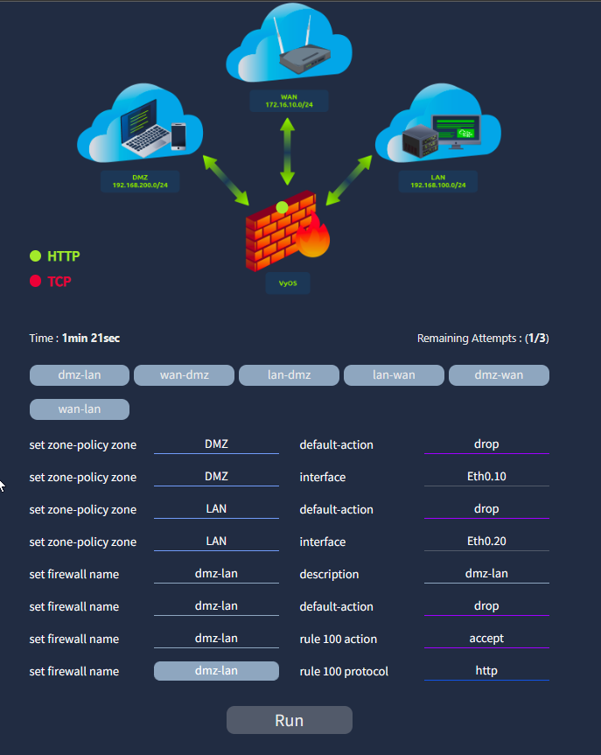
VyOS zone-based firewall lab — network topology and zone-policy configuration interface

3.2 Zone Policy Configuration
The following VyOS commands were configured to establish the zone-based firewall:

Zone definitions:
set zone-policy zone DMZ default-action drop
set zone-policy zone DMZ interface Eth0.10
set zone-policy zone LAN default-action drop
set zone-policy zone LAN interface Eth0.20

Firewall ruleset (dmz-lan):
set firewall name dmz-lan description dmz-lan
set firewall name dmz-lan default-action drop
set firewall name dmz-lan rule 100 action accept
set firewall name dmz-lan rule 100 protocol http

- The configuration enforces a deny-all default posture per zone, with explicit permit rules required for each permitted traffic flow.
- Rule 100 permits HTTP traffic from the DMZ to the LAN — all other protocols are dropped by the default-action.

3.3 Rule Verification and Flag
- After configuring and running the zone-policy rules, the lab verified the configuration by testing traffic flows against the defined rules.
  - The correct configuration was accepted and the completion flag was returned: THM{M05tly_53cure}.

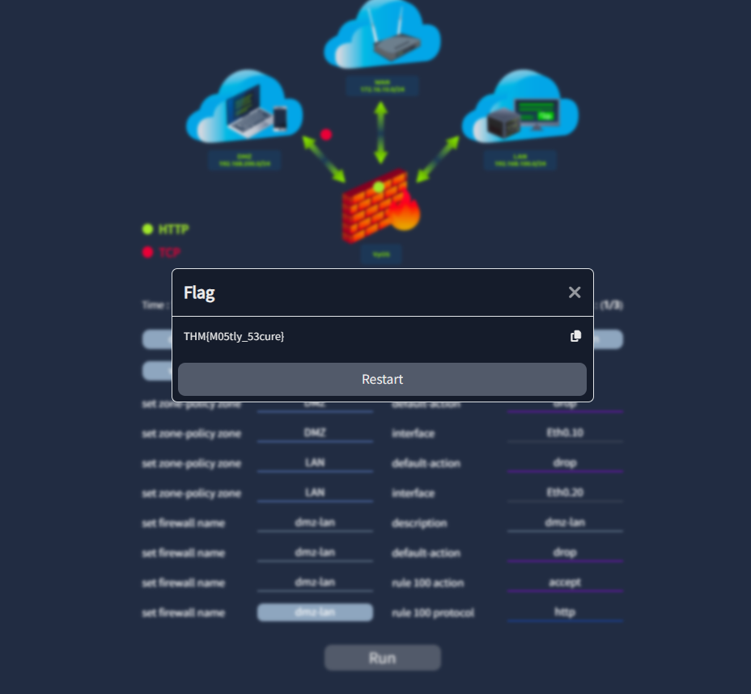
Flag captured — THM{M05tly_53cure} — confirming correct zone-policy configuration

4. Lab Completion
- The TryHackMe Secure Network Architecture room was completed in full:
  - 8 tasks completed
  - 112 points earned by sawant052.

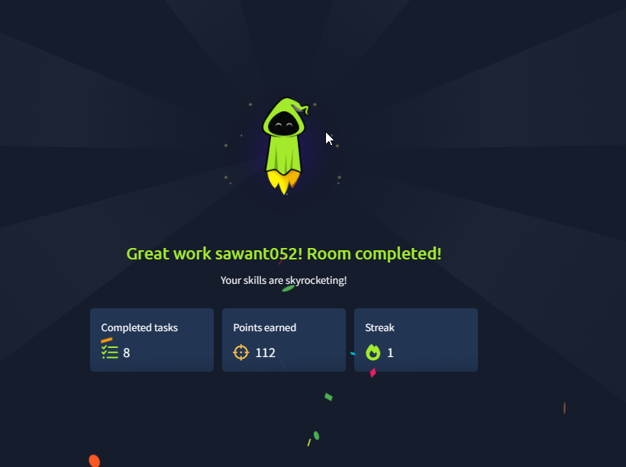
TryHackMe — Room completed: 8 tasks, 112 points, user sawant052

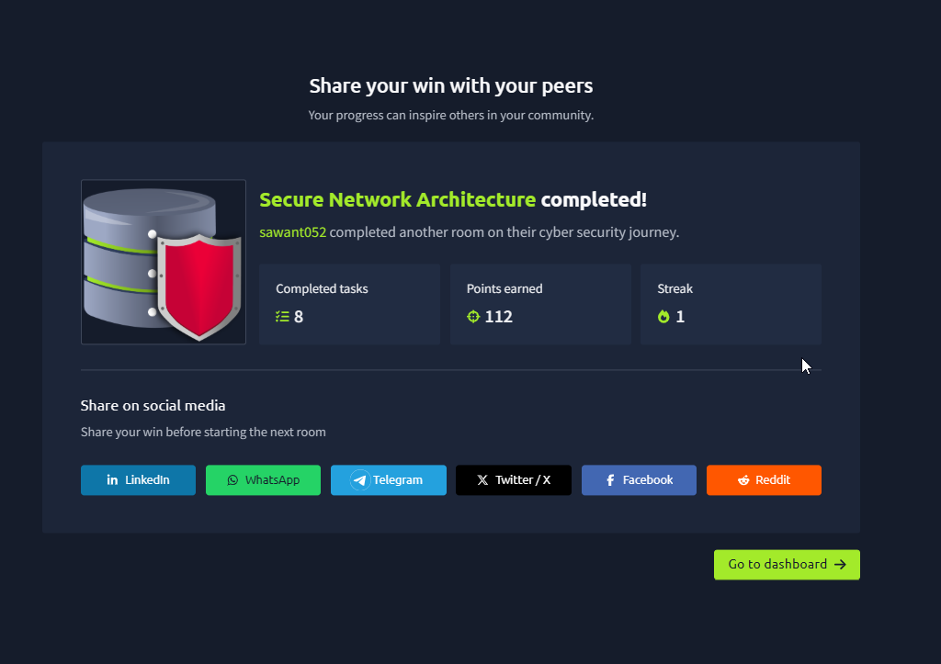
TryHackMe — Secure Network Architecture completion certificate

5. Key Findings and Lessons
- Zone-based firewalling is more scalable than interface-based rules:
  - policies are defined per zone pair rather than per interface
  - reducing configuration complexity as the network grows
- Default-deny posture is critical
  - setting default-action drop on every zone means no traffic is permitted unless explicitly allowed
  - eliminating the risk of accidental permissive rules
- Interface-to-zone mapping (Eth0.10 → DMZ, Eth0.20 → LAN) is the foundation of segmentation
  - physical or logical interfaces must be correctly assigned before any policy takes effect
- Six inter-zone rulesets are required for three zones (dmz-lan, lan-dmz, wan-dmz, dmz-wan, lan-wan, wan-lan)
  - each direction is independent and must be configured separately
- Protocol-level granularity
  - rule 100 permitted HTTP only; TCP in general was dropped
  - demonstrating least-privilege traffic control at the protocol level

6. Mapping to Deliverable 3
- The lab findings directly support the Network Segmentation Plan (Deliverable 3) as follows:
  - VLAN segmentation:
    - lab zones (WAN/DMZ/LAN) mirror the GlobalTech Corp VLAN design (User, Server, Finance/HR, DMZ, Guest, IoT VLANs)
  - ACL implementation:
    - VyOS firewall rulesets are the functional equivalent of ACLs on a Cisco L3 switch
  - both control inter-segment traffic by protocol and direction
  - Default-deny:
    - the lab's default-action drop policy mirrors the ACL deny-all baseline recommended in the segmentation plan
  - Traffic verification:
    - the lab's Run function tested rule effectiveness, equivalent to the ping/traceroute verification steps documented in the segmentation plan

